
coal lab 3
Lab Tasks

September 4, 2025

Name: Saqba Yasmin

Sap: 63476
Submitted to: Maam Rehana

COAL LAB 3
TASK 1:
.org 100h
.data
.code
main proc
mov dl,'a'
mov ah,2
int 21h
mov dl ,10
mov ah,2
int 21h
mov dl ,13
mov ah,2
int 21h

mov dl,'l'
mov ah,2
int 21h
mov dl ,10
mov ah,2
int 21h
mov dl ,13
mov ah,2
int 21h

mov dl,'i'
mov ah,2
int 21h
mov dl ,10
mov ah,2
int 21h
mov dl ,13
mov ah,2

mov dl,'s'
mov ah,2
int 21h
mov dl ,10
mov ah,2
int 21h
mov dl ,13
mov ah,2

mov dl,'h'
mov ah,2
int 21h
mov dl ,10
mov ah,2
int 21h
mov dl ,13
mov ah,2

main endp
end main
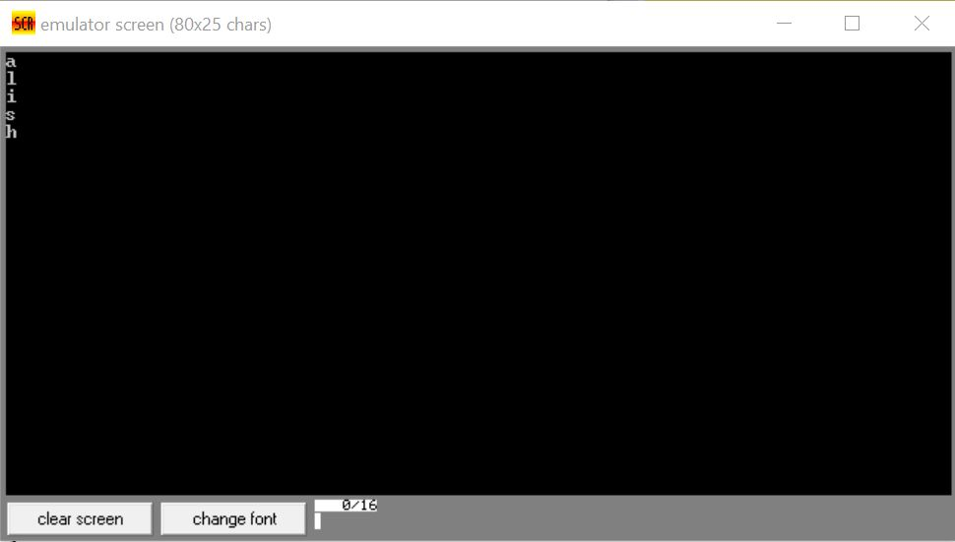
Task 2:
.org 100h
.data
.code
main proc
mov dl,'s'
mov ah,2
int 21h

mov dl,'a'
mov ah,2
int 21h

mov dl,'q'
mov ah,2
int 21h

mov dl,'b'
mov ah,2
int 21h

mov dl,'a'
mov ah,2
int 21h

mov dl," "
mov ah,2
int 21h

mov dl,'y'
mov ah,2
int 21h

mov dl,'a'
mov ah,2
int 21h

mov dl,'s'
mov ah,2
int 21h

mov dl,'m'
mov ah,2
int 21h

mov dl,'i'
mov ah,2
int 21h

mov dl,'n'
mov ah,2
int 21h

main endp
end main
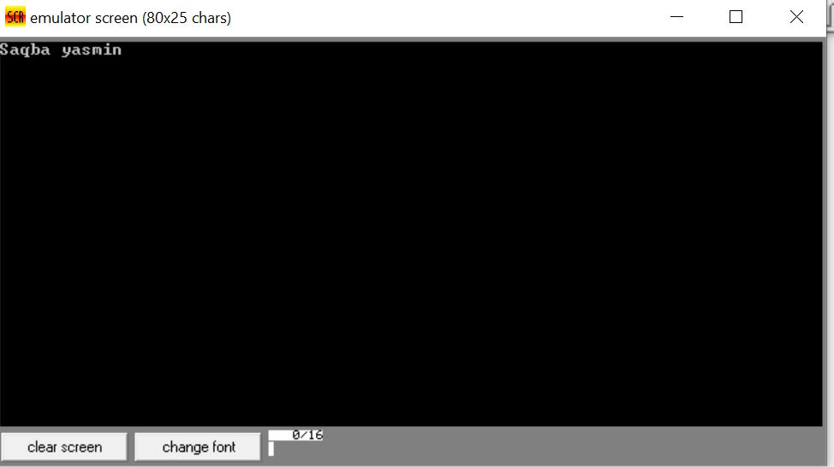
Task 3:
.org 100h
.data
.code
main proc
mov ah ,1
int 21h

mov dl,al
sub dl,32

mov ah,2
int 21h

main endp
end main 